**CSC 417 Unit 1 Day 4 Outline**

1. Advanced Computer Games
   1. Behavior trees
      1. Advantages
         1. Provide for overall flow of decision making
         2. Facilitate “fallback tactics” (i.e. what to do if an action fails)
         3. Handle complexity better than an FSM
            1. Easier to debug – can follow tree to see exactly how we arrived at a node
      2. Disadvantages
         1. Can lead to AI “holes” if not carefully planned
            1. Skyrim – NPCs notice if you steal an item in front of them, but not if there is a bucket on their head blocking their vision
      3. Definition
         1. 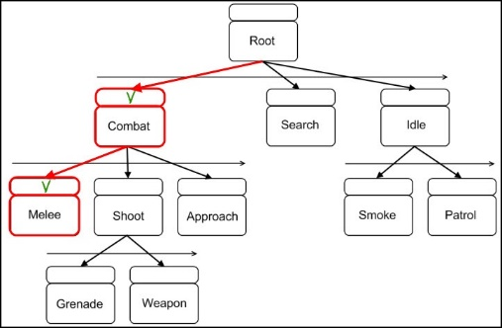Directed acyclic graphs
            1. Connections are “one-way”
            2. No cycles (circles)
         2. During each “tick” (iteration of the game’s logic loop), the system traverses the tree to identify the appropriate node to process
         3. To avoid traversing the entire tree during each update, the program can store the currently active node
      4. Components
         1. Composite nodes
            1. Have one or more child nodes
         2. Decorator nodes
            1. Have exactly one child node
            2. Can transform result from, terminate, or repeat the child node
         3. Leaf nodes
            1. No children
            2. Define the actual actions to be taken
            3. Can call another behavior tree (facilitates the creation of modular, reusable trees)
         4. Sequence node
            1. Subtype of composite node
            2. Indicates a sequence of actions (child nodes) to be performed (AND)
            3. Actions may be tests/checks
         5. Selector node
            1. Subtype of composite node
            2. Perform actions specified by child nodes until once succeeds (OR)
   2. Search and Knowledge
      1. Humans play games via a form of pattern recognition
      2. Humans and computers play chess differently
         1. Humans employ multiple levels of heuristics
         2. Imprecise human heuristics must be translated to a mathematical equivalent (evaluation function)
         3. Humans are not always thinking in terms of *math*-based heuristics
         4. AI *must* think in terms of math
      3. While search is a crucial AI concept, it does not seem to allow computers to solve problems the *same way* that people do (*at least internally…)*